Project 2: Power BI Data Modeller
1. Schema Type: Star Schema
In this project, I used a star schema design where Sales_Fact acts as the central fact table. All the dimension tables are directly connected to it, which keeps the model simple and improves performance in Power BI.
I also included Returns_Fact as a second fact table instead of treating it as a dimension. It is connected to Sales_Fact through SalesID and shares the Date_Dim table. There are two relationships with Date_Dim:
one active (using DateKey)
one inactive (using ReturnDateKey)

2. Relationships and Filter Flow
2a. Active Relationships
All relationships between dimension tables and fact tables are set to one-to-many (1:M) with single-direction filtering (Dimension → Fact). This helps avoid confusion and ensures filters behave as expected.
The main relationships are:
Customer_Dim → Sales_Fact (via CustomerID)
Product_Dim → Sales_Fact (via ProductID)
Region_Dim → Sales_Fact (via RegionID)
Date_Dim → Sales_Fact (via DateKey)
Sales_Fact → Returns_Fact (via SalesID)
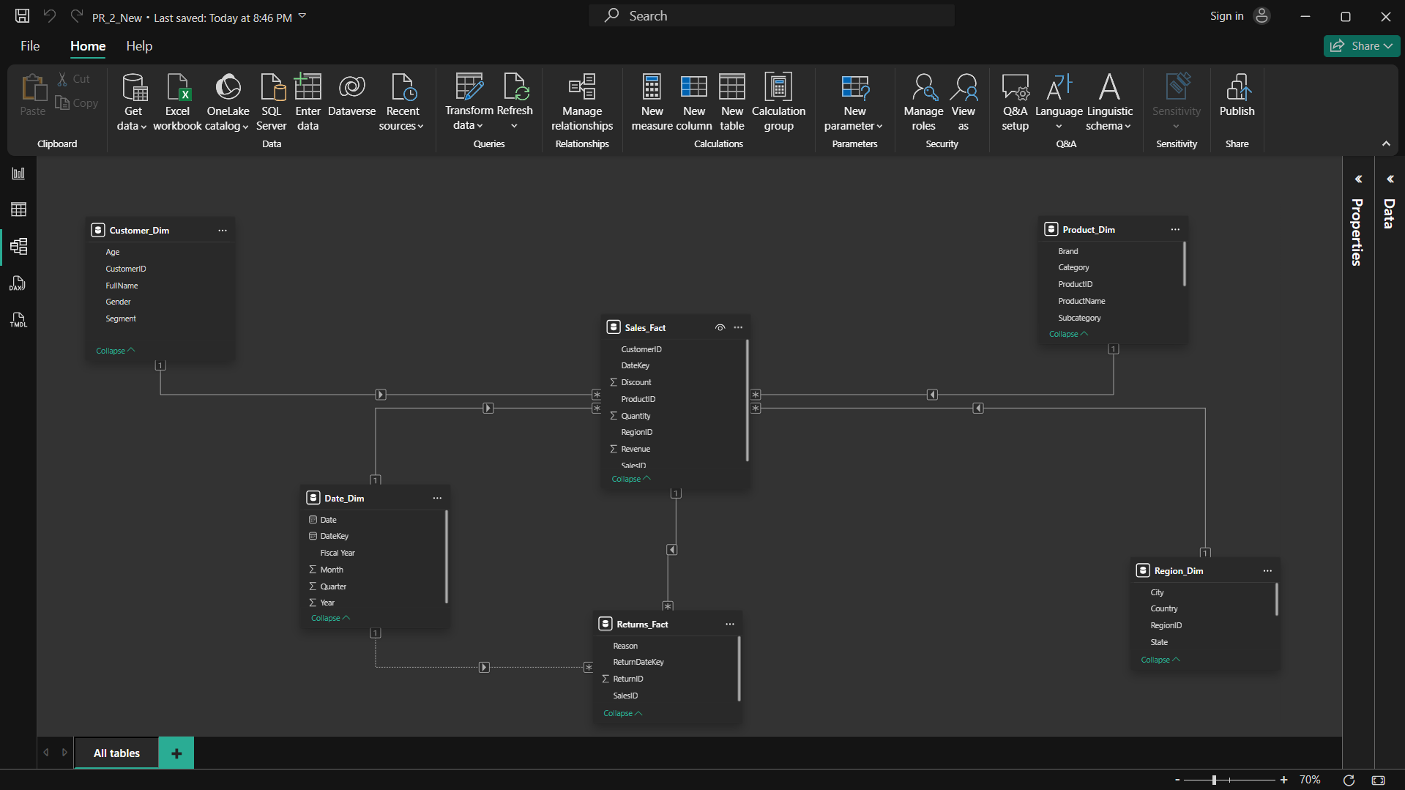
There is also a relationship between Date_Dim and Returns_Fact using ReturnDateKey, but this is kept inactive.

2b. Inactive Relationship (Returns_Fact – ReturnDateKey)
The relationship between Date_Dim[DateKey] and Returns_Fact[ReturnDateKey] is set as inactive. This is done to avoid ambiguity, since Power BI allows only one active relationship path between tables.
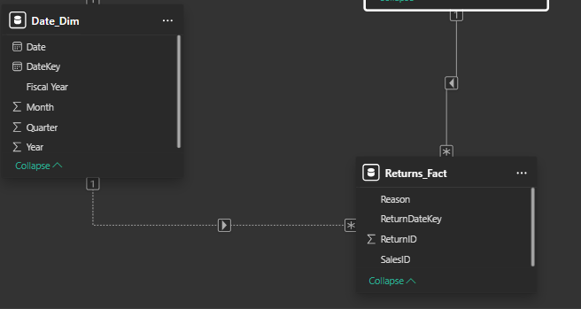
2c. Bidirectional Filters
I have not used bidirectional filtering in this model. All relationships use single-direction filtering to avoid circular dependencies and unexpected results.

Bidirectional filtering is only useful in special cases like many-to-many relationships, which are not present in this model.

3. Data Categories and Hierarchies
To make reporting easier, I created hierarchies and assigned proper data categories:
Region_Dim
Country (Country category)
State (State/Province)
City (City)
Hierarchy: Country → State → City

Date_Dim
Hierarchy: Year → Quarter → Month → Date
Product_Dim
Hierarchy: Category → Subcategory → Product Name
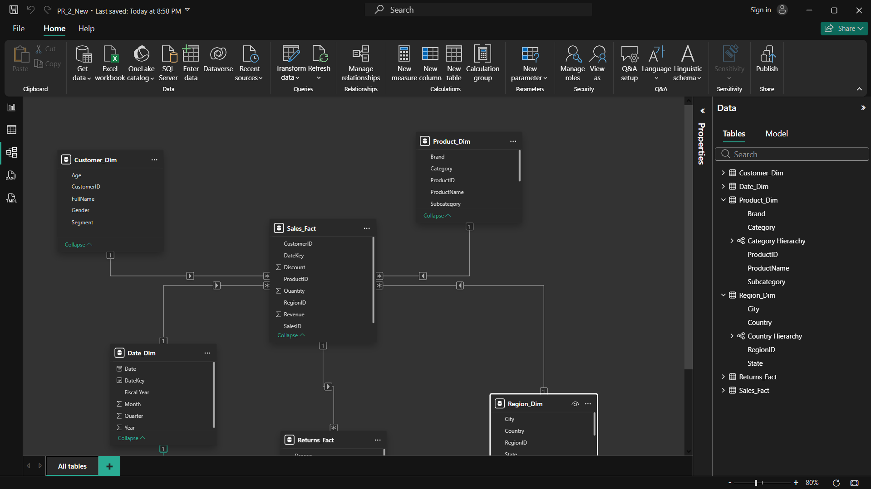
These hierarchies help with drill-down analysis in visuals.

5. Verification Using Matrix Visual
To check if the model was working correctly, I created a Matrix visual and tested different scenarios:
Sales by Product Category and Region → confirmed data is showing correctly across all categories and regions
Returns by Fiscal Year → verified that USERELATIONSHIP() works for return date analysis
Revenue by Customer Segment → confirmed filters from Customer_Dim are applied properly
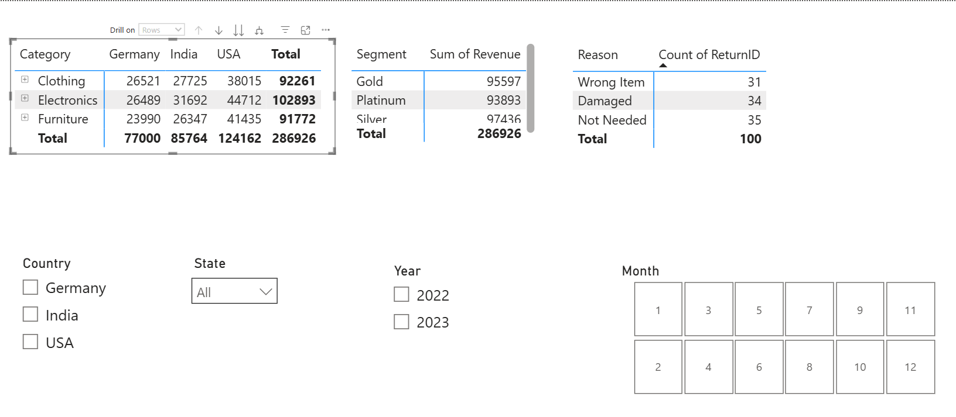

Add Slicer and Apply Slicer
